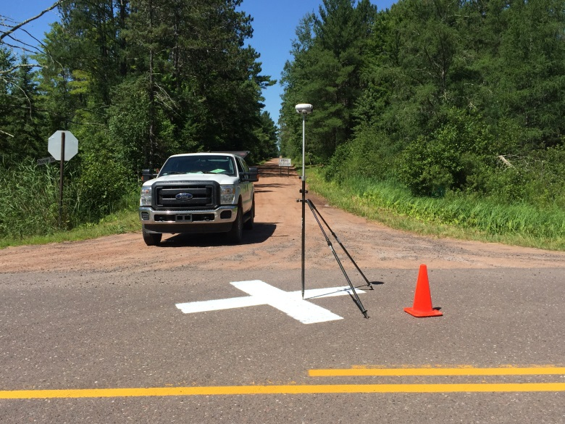
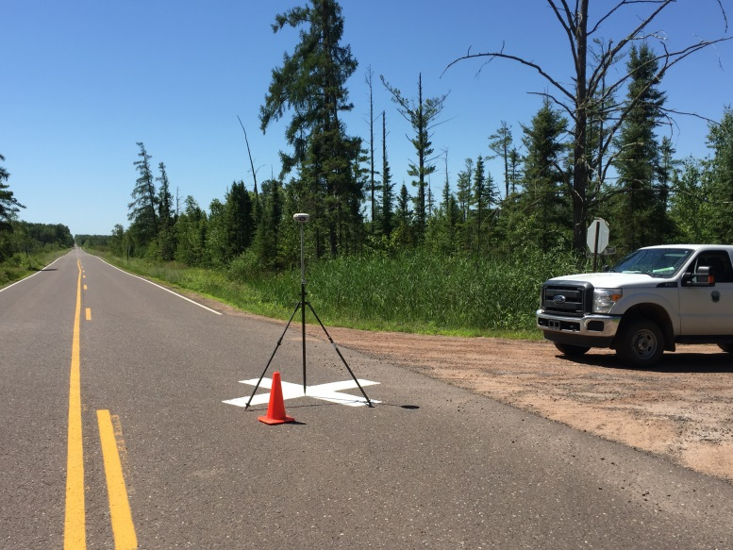
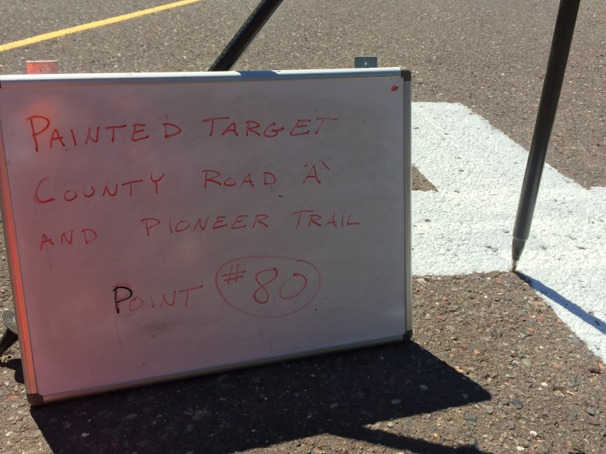
Site | 89
Northing | 112867.186
Easting | 154653.633
Elevation | 968.32899999999995
Description:
Bridge Deck & White Line (Truck Faces East on Pioneer Trail)

