City of Superior/Douglas County Pictometry Flight 2013
Flown April/May 2013
Douglas County Coordinate System
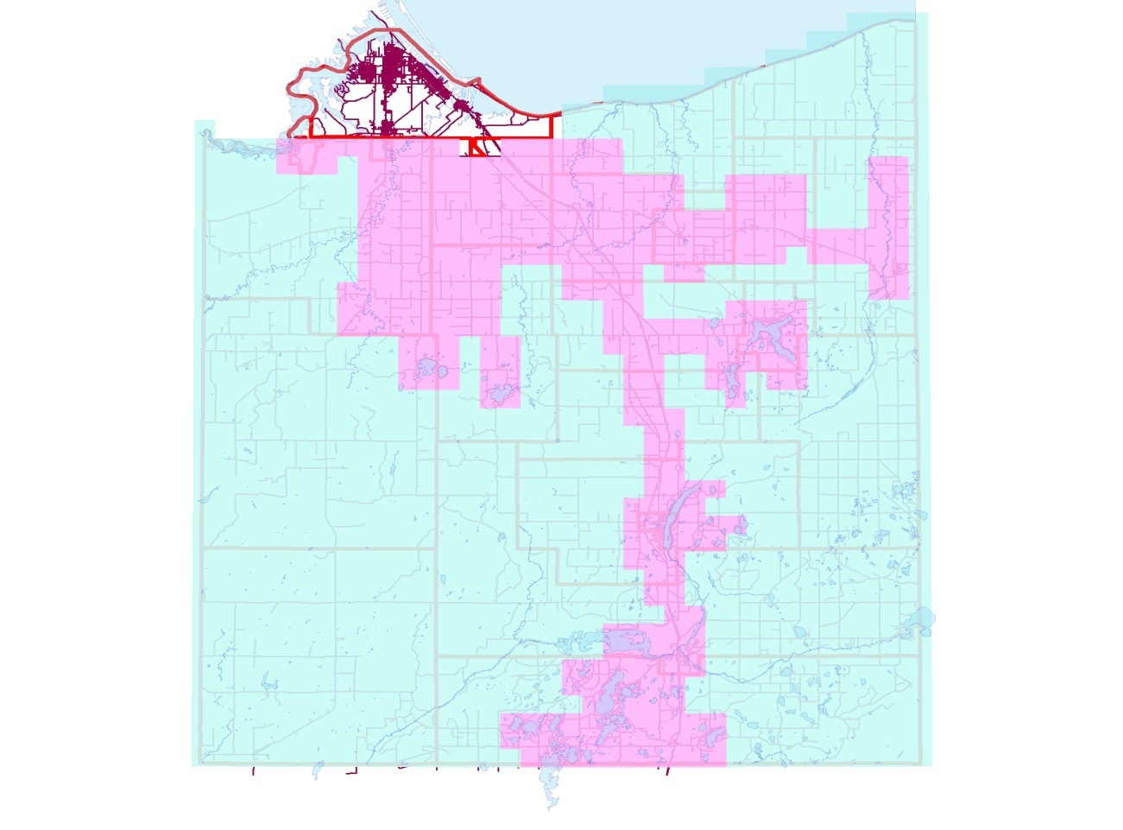
Ortho File Breakdown

Ortho Resolution Legend
City of Superior = 4”/pixel
Pink Sectors = 4”/pixel
Turquoise = 9”/pixel
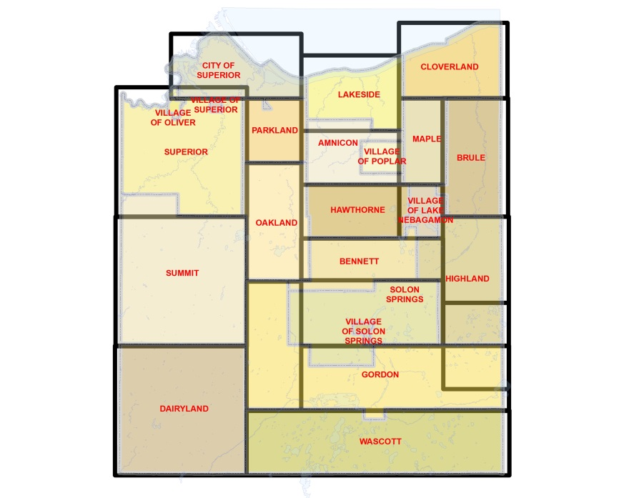
About Geospatial Data
The City of Superior/Douglas County prepares and uses this data for its own purposes. This data displays general boundaries and may not be appropriate for site specific uses. The City/County uses data believed to be accurate; however, a degree of error is inherent in all maps. This data is distributed "AS-IS" without warranties of any kind, either expressed or implied including, but not limited to, warranties of suitability to a particular purpose or use. Detailed on-the-ground surveys and historical analysis of sites may differ substantially from this data. The user of the provided information may find it desirable and beneficial to consult other sources and engage professionals to analyze, and provide advice relating to, the information made available by the City/County and other data sources.
You may download the ESRI ArcExplorer free of charge.
http://www.esri.com/software/arcgis/explorer/index.html

Geospatial Data Downloads
http://www.ci.superior.wi.us/index.aspx?nid=474

Douglas County Survey Media Explorer
http://www.cosdc.us/surveyors/

Douglas County GIS Online Site
http://douglascowi.wgxtreme.com/

