Issues with ArcMap and Microsoft Objects
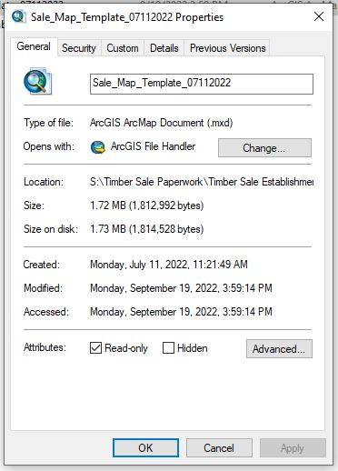
Map document that we use within the office as a template for various projects (timber sale maps, site preparation maps, etc). Issue not specific to the timber sale map template. Document is set up as ‘read only’, user must save a copy elsewhere to make edits.
*There have been many previous versions of this map through the years where no issues occurred. Older versions of ArcMap. Is this a 10.8 issue? Not compatible with older Microsoft software?
I redid the timber sale map template in July to create a current version in ArcMap 10.8.1. Eliminated any Word objects and used only Excel objects, recreated header information to be stored within the document rather than linked to an external document.
Added shapefiles/layers are linked to both the S: drive and SDE.
Created Excel objects using Insert > Object > Create New > Microsoft Excel Worksheet/Microsoft Excel 97-2003 Worksheet
- There are several Microsoft Excel object options and I can’t quite remember which I picked? I think I’ve tried both...
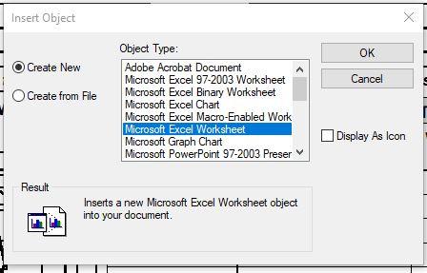
I initially considered the issue being several people using the template at once and those choosing to ‘create new’ versus ‘create from file’ would create a unique document link for each person that saved a copy. Not actually sure how ArcMap stores these external data links…

Some of the guys here started saving their map documents locally to the desktop instead of the S: drive and have less problems. I ran some ‘tests’ with 2 documents saved to different places and had the following observations that I sent along in my email a couple weeks ago:
With having multiple screens, I often have a window of file explorer open on one screen. This is how I noticed occasionally (few times a day?) that the file explorer window will crash and close. I’m not sure what causes the crash, but when it occurs, that is when the issue happens in the template. I’ve reproduced this error a few times. The observations I’ve made leaving both a locally saved map document, one saved on the S drive, and the file explorer window open on the same screen:
- The crash does not seem to occur at a set interval. It once happened in 15 minutes and another time it took almost 2 hours of leaving it open (file explorer).
- If I save the map document to my desktop, the Excel objects are unaffected.
- If I save the map document to the S drive, all Excel data is lost when the fire explorer crashes. If I click on the Excel object, I get the attached error. If I close the document and re-open it, the Excel data is completely gone.
- In both cases, there is a visible blip/blinking/readjusting on the map document as if the document is trying to reload or re-establish a connection.

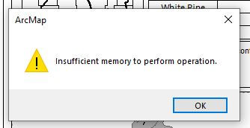
I don’t think the issue is caused by the file explorer, but it crashing provides an indicator that something is happening behind the scenes. It doesn’t seem to be isolated to one computer, as almost all the foresters here have had issues with it at one point or another. Could this be an issue with the server? A driver issue with Microsoft talking with Arc?

*Tested it again this morning (11/17/2022) with a copy saved to the S: drive, file explorer crashed, received the above error, but when I went to open the map document again the Excel objects were still there and I could edit them normally. Had recently saved before the blip.
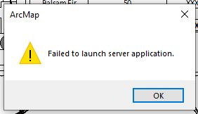
Reopened map and file explorer at 8:50 am, blip at ~9:18, different error appeared (below), affected both desktop version and S: drive version. Closed and reopened both versions and same error message appeared, but Excel objects are still visible. Closed them both. Restarted computer and both were working normally after restart. File explorer did not crash in this instance.

Opened both maps again at 9:27, file explorer crash at ~11:00. Desktop version was fine and S: drive version gave ‘Insufficient memory…’ error and Excel objects were missing upon reopening. 11/17/2022
Office 365 installed on November 18, 2022
Saved a new copy of the sale map template to the S: drive. Made no changes to the Excel objects.
~12:30, not sure when, but Test 4 version failed. Noticed at 1:47, but file explorer hadn’t crashed. I had left my computer to eat lunch and it had gone to sleep.
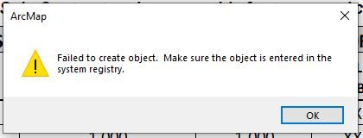
Created another test document. Decided I would try deleting the Excel objects and creating new with the Office upgrade and received the following error when I selected ‘Microsoft Excel Worksheet’. Also tried it with several object options and got the same error.

Getting the ‘Failed to Launch Server Application’ error now no matter where I save it to or how long I leave the map document open.
Recreated the Excel objects.

