**WebClock Employee User Guide**



**Last Updated by City of Superior – June 2021**

**Step 1: Log In**

**Navigate to the WebClock at:** [**https://273440.tcplusondemand.com/app/webclock/#/EmployeeLogOn/273440/1**](https://273440.tcplusondemand.com/app/webclock/#/EmployeeLogOn/273440/1)

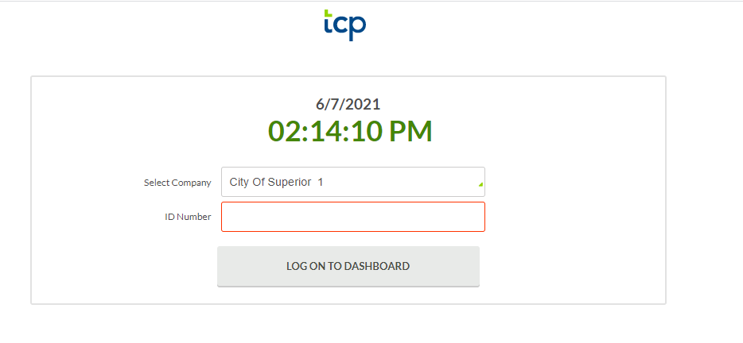

Enter your **Employee ID number.** Then click **Log on to Dashboard.**

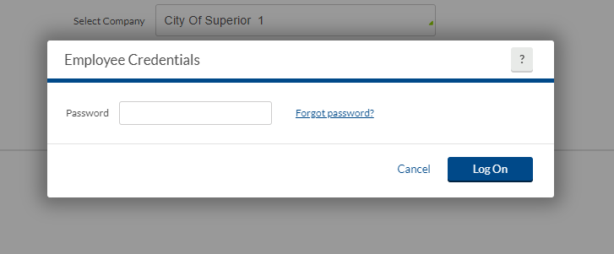

Type in your **password.** If this is the first time you are signing in, click **Log On** which will prompt you to set a password.

Type in your desired **password** and click **Submit**.

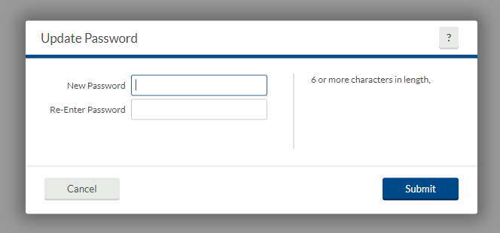

You will now see your dashboard.

A password might be provided to you for your fist log in. If so, the first time you log in, make sure to update your password.

To change your password, click **My Options** in the top right hand corner.

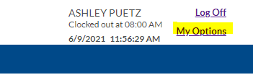

You will be brought to the employee options page. Drop down the password menu and enter your current and new passwords to update.

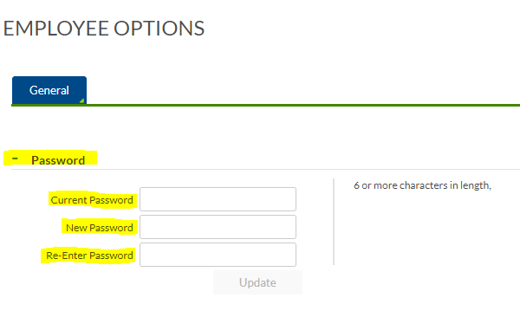

**2. Requesting Time Off**

Navigate to **Requests** on the blue ribbon.

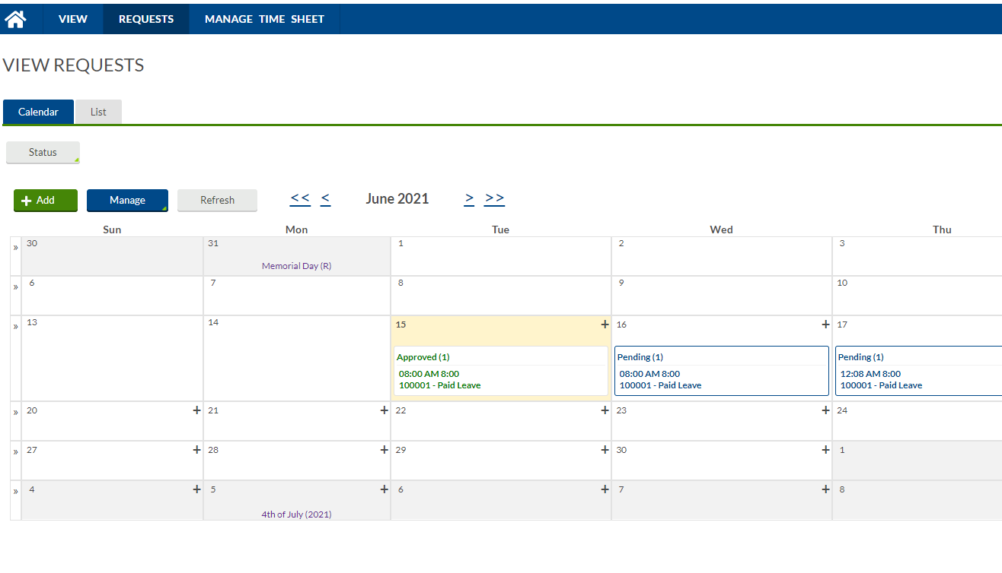

Either click the **plus sign or double click** on the date you want or click on the day and then click **Add**.

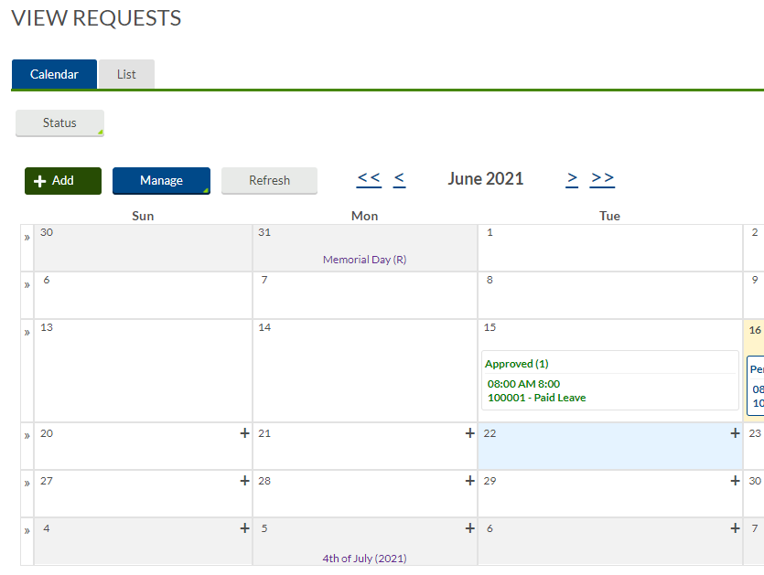

The **Add Employee Request** Box will pop up on your screen. Items outlined in red are mandatory. Fill it out with your desired request. Note that the leave code box should include all of your leave codes (Paid leave, sick leave, floating holiday, bereavement, etc.) available to you. If something appears to be missing, contact Finance/HR.

Click **Save**.

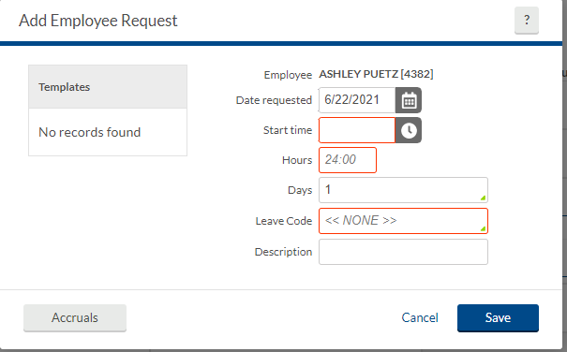

Once your manager approves the request, the time will populate on your timesheet.

**3. Manage Time Sheet**

**Click on Manage Time Sheet in the blue ribbon.** If you have been assigned to an active recurring schedule, you will have prepopulated time here. If this is not the correct schedule, please contact Finance/HR with your correct schedule so it can be updated. If a schedule does not prepopulate, a recurring schedule was not assigned to you. You will need to manually enter your worked hours each shift. If you would like a recurring schedule assigned to you, please contact Finance/HR.

You can **Edit** the time already entered. You can **clear** the time entered and you can **add** time. You can also **copy** and **paste** your time to another date.

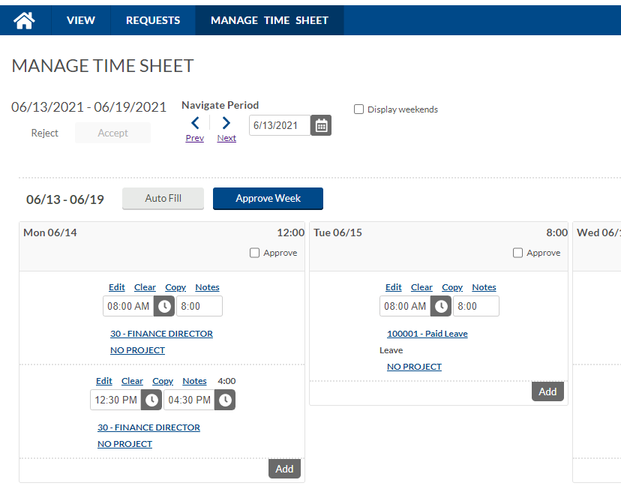

The edit feature allows you to change everything in the box below.

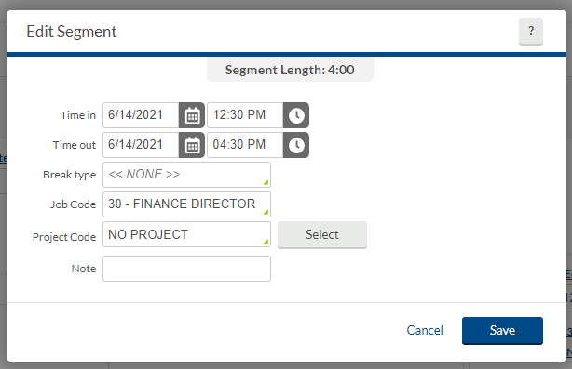

If you need to add a project code click **select** and then choose from the drop down menu. If no project code is needed, leave the defaulted “No Project” selection in the project code box or choose from the project code listing if it does not prepopulate.

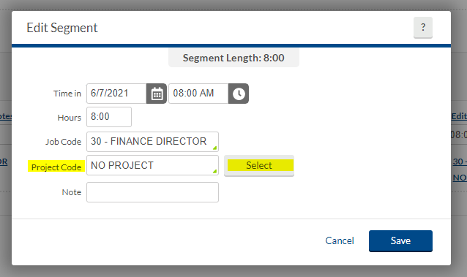

If you need to switch the type of hours you are recording, for example, vacation or a different job such as light to medium equipment operator, click on the box next to Job Code to see the drop down menu of options. These options should be customized to you. If you are missing or have something extra, please notify HR/Finance.

Official record of employee accruals are kept in Central Square. Accruals are imported into Central Square after each payroll cycle to keep them updated. TCP will not allow employees to take banked time that is not available to you. If the system is not allowing you to take banked time that you believe is available, contact HR/Finance.

If you worked a job that requires a different rate of pay, enter the special rate in the **note** field.

When you are done making changes, click **Save**.

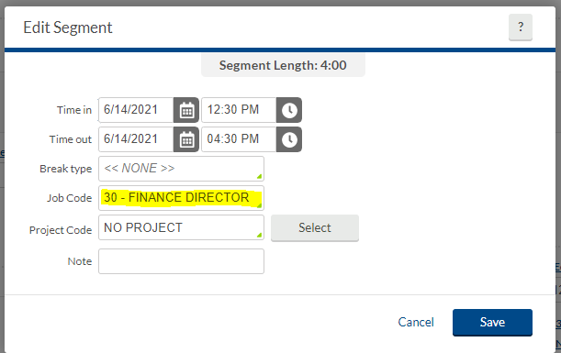

To add time click **Add**. You can also click **Auto Fill** which will populate your schedule with the previous week’s hours.

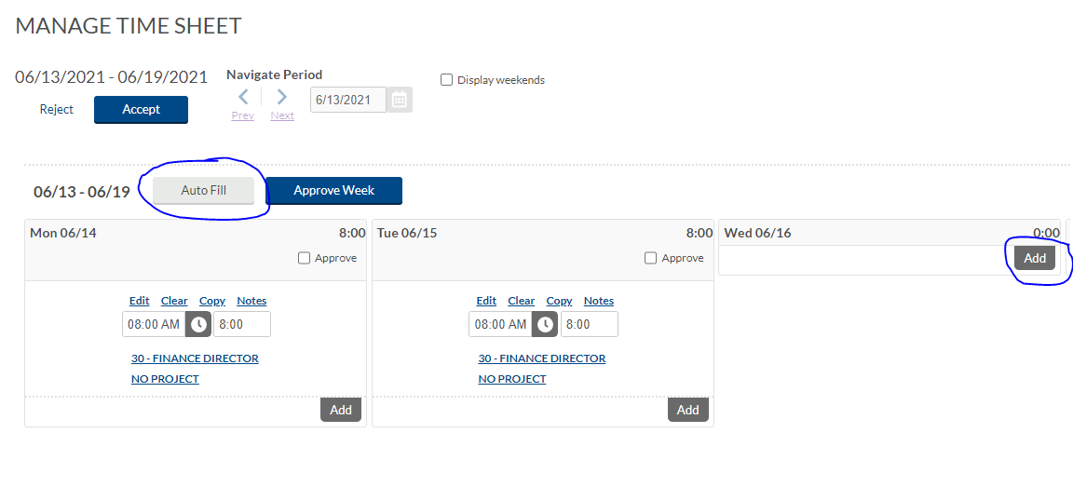



**Lunch Breaks**

When you take a lunch, enter your time for the day as two segments. One segment of time prior to your lunch and one after. For employees with a regular schedule that includes a lunch, these two segments will automatically populate.

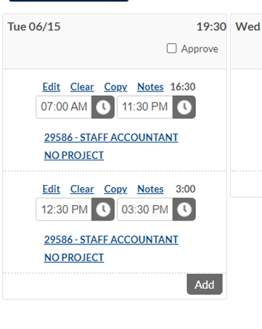

**4. Comp Time Allocation**

If you are eligible for comp time and you are entering time for a week with eligible comp time hours, look at the grey bar under the manage time sheet entry.

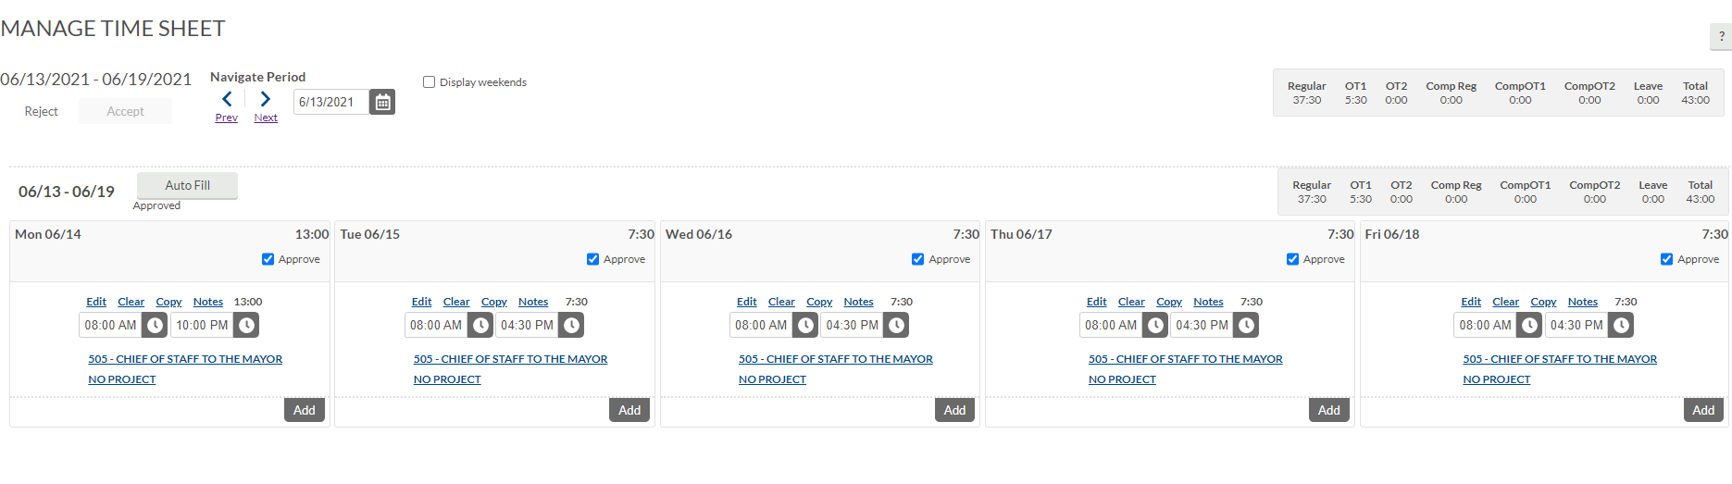

This section shows the breakdown of your hours. In this example we will move overtime hours to comp.

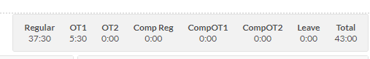

Click **View** in the blue ribbon and click on **Comp Time Allocation** or **hours** in the grey ribbon.

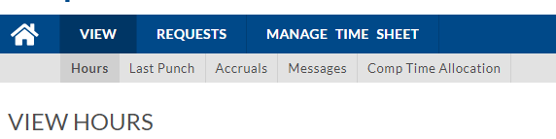

If you clicked on hours, then click **Navigate to Comp Time Allocation** on the right hand side of the screen.

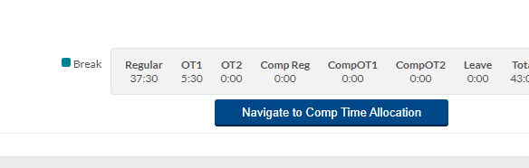

Your eligible overtime hours will appear on this screen.

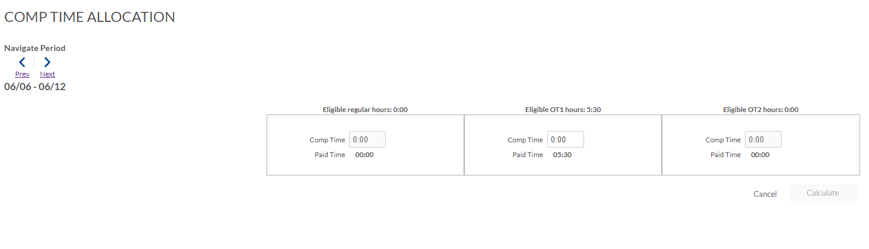

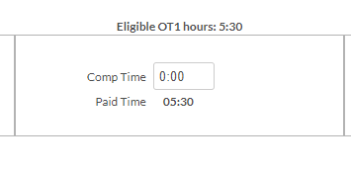

Enter the amount of hours you would like to be Comp Time instead.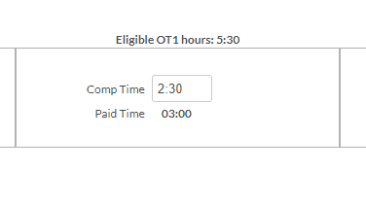

Then click **Calculate** on the Comp Time Allocation Summary pop up.

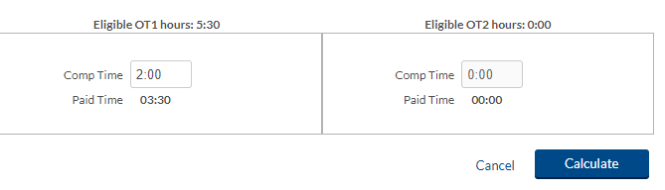

**5. Approval**

Once your hours for the week are correct you can approve and accept. In order to approve, either select **approve** on each day or click **approve week**. Once the entire week is approved, click on **accept.**

