If you see this message while trying to download from our site.

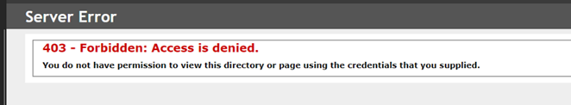

We do not deny access to the files (and the downloads definitely work), typically this is on the user side. Possibly a firewall setting (your IT staff may need to get involved with that), browser setting or a security certificate.

Sometimes the user gets prompted to accept a security certificate, if OK is clicked. That will cause it to fail. To resolve this clear your cookies and try again when prompted for the certificate hit cancel and it should start the download.

