Date: July 29, 2026

To: Chris Carlson, Collection System Manager

Copy: Asher Fink, Hydrologic & Hydraulic Modeler

From: Jennifer Kampa

Re: Missing / Suspect Storm Sewer Utility Data

The attached map shows the initial model schematic (not including open Faxon Creek) for the Faxon Creek Watershed XP-SWMM model. Pipes with missing GIS slopes and/or inverts were interpolated based on adjacent pipe slopes and inverts. The pipes highlighted in yellow and the manholes highlighted in orange on the attached map need to be surveyed or record drawings need to be checked for missing data. We have the following questions/comments:
- All pipes are assumed to be circular.
- Outfalls and Faxon Creek will be surveyed by LHB.
- Material for pipe ST3B0470-ST3B127A is listed as CHDPE. We assume that means corrugated high-density polyethylene with a roughness coefficient of 0.024.
- RCP is assumed for pipes with the material field left blank.
- Pipes with missing diameter
- ST090018-ST090019: Assumed 60” diameter since downstream pipe is 60”. Upstream pipe is 54”, but additional pipe comes in at upstream location.
- ST3A0156-ST3A0157: Assumed 24” diameter since both upstream and downstream pipes are 24”.
- ST050085-ST050086: This is the most upstream pipe of the run. Assumed 30” diameter since the next downstream pipe is 30”.
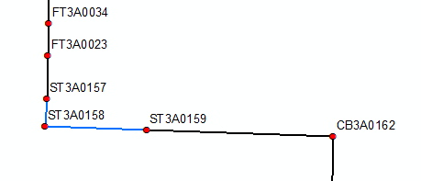
- Pipes with missing slopes
- ST3A0158-ST3A0157: used same slope as downstream pipe
- ST3A0159-ST3A0158: used same slope as upstream pipe
- We suspect that ST3B0004 has an incorrect invert listed in the GIS. The invert of 646.574248 feet is likely incorrect. We calculated a new downstream invert of 631.0096 feet based on the upstream invert and slope. The revised profile is shown below.
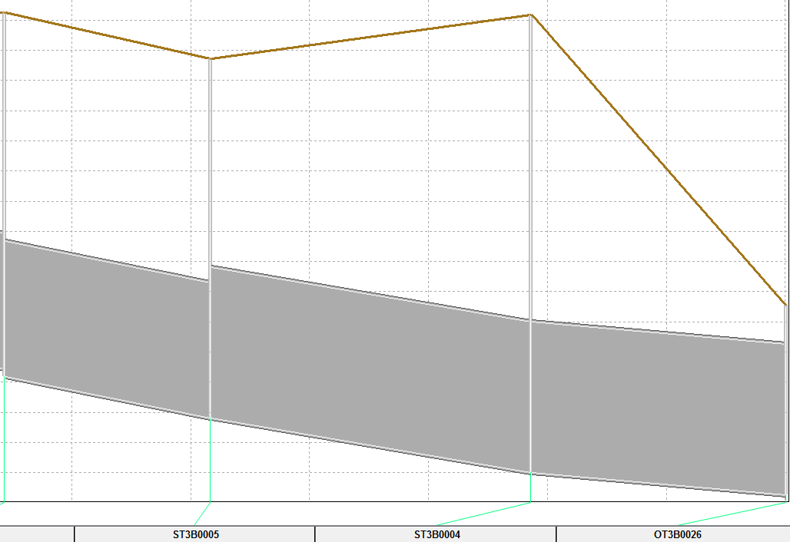
- We suspect that the pipe from ST3B0082-ST3B081C has incorrect inverts listed in the GIS because this pipe is higher than the adjacent pipes. If we match the inverts to the adjacent pipes, this pipe will have a negative slope. The profile is shown below. Please advise on how to proceed.
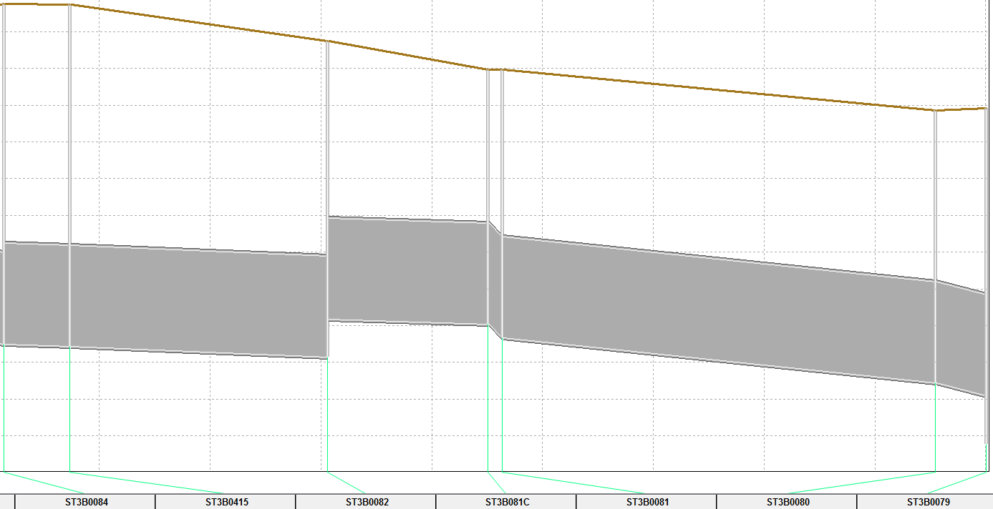

- The invert of ST090062 appears to be too high. We have changed it from the GIS value of 649.77 feet to 639.8164 feet using the upstream and downstream slopes. The resulting profile is shown below.
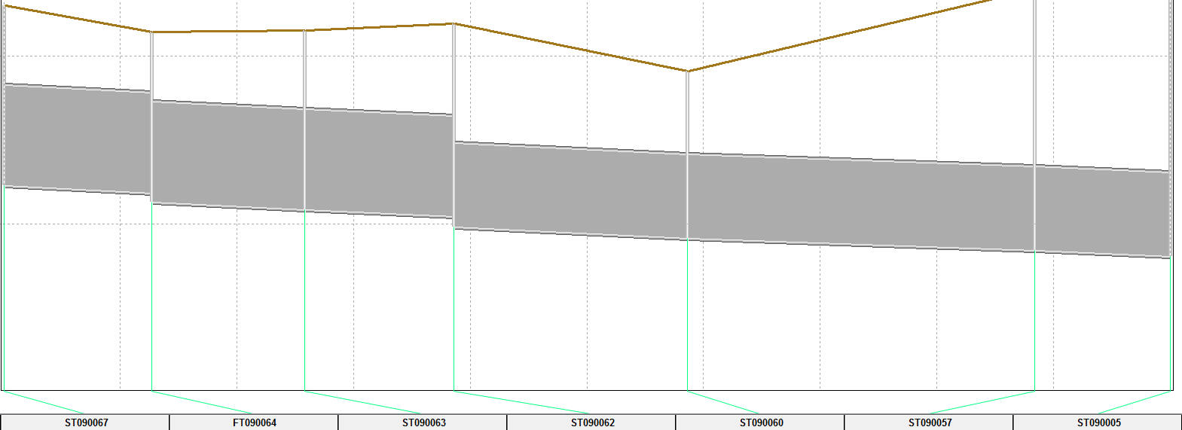
- The inverts and slope are unknown for ST090014-ST090015. We have calculated the slope to be 2.27202% using the interpolated upstream and downstream inverts, which are based on the upstream and downstream slopes.
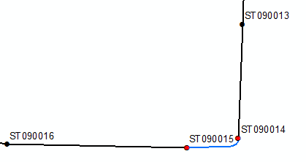
- We suspect an error in the invert value for ST3B0420 because it causes 3 upstream and 2 downstream pipes (interpolated due to missing inverts) to be lower than the adjacent pipes. The profile is shown below. Please advise on how to proceed.
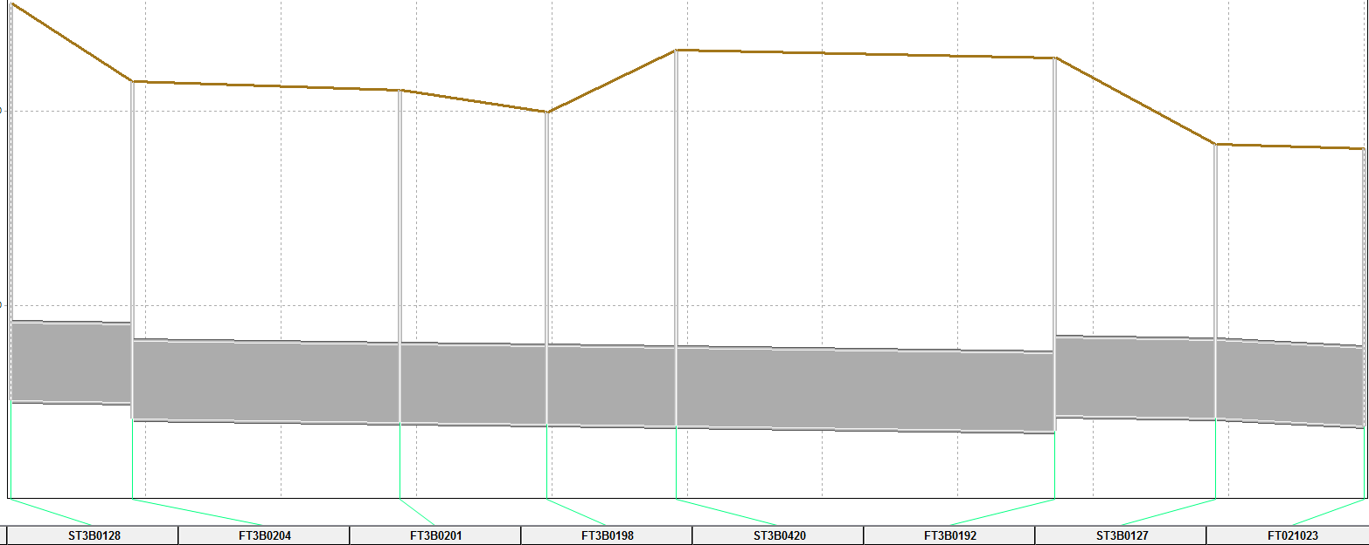
- The pipe from FT3B0472-ST3B0470 is listed as a 36” diameter in the GIS, but both upstream and downstream pipes are 48”. This looks to be a GIS data entry error because the labels field says “300’, 48”, .59%”. We have changed the pipe diameter to 48” in the model.
- We suspect the invert value of 651.596 feet listed in the GIS for ST3B081C is too high. It is also probable that the invert of ST3B0081 and ST3B0080 are also too high since they cause the middle section of pipe in the profile shown below to be higher than the adjacent pipes. Please advise on how to proceed.
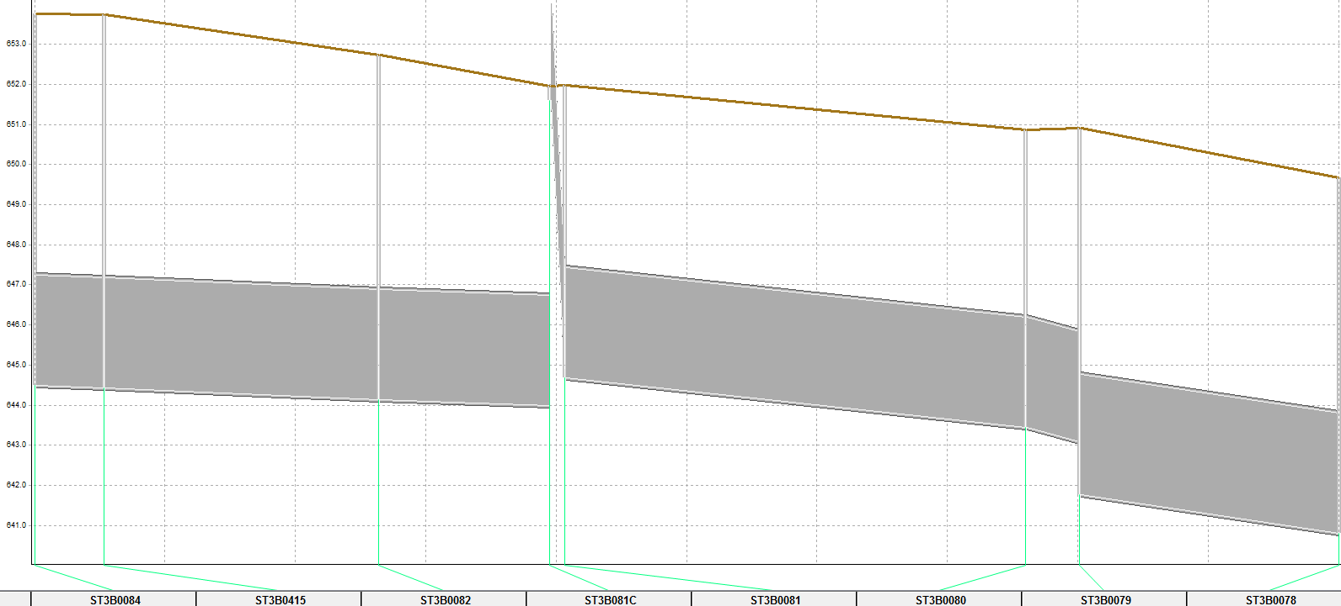
- Slopes and inverts are missing between ST090078 and FT090068. Should we assume a constant slope between these 2 manholes and interpolate for all 6 pipes, or should they be surveyed?
- The pipe run from ST090062 to ST090005 is listed as 60” in GIS, but the 3 upstream pipes are 72”. Is this an error? All pipes have a similar slope. The profile is shown below.
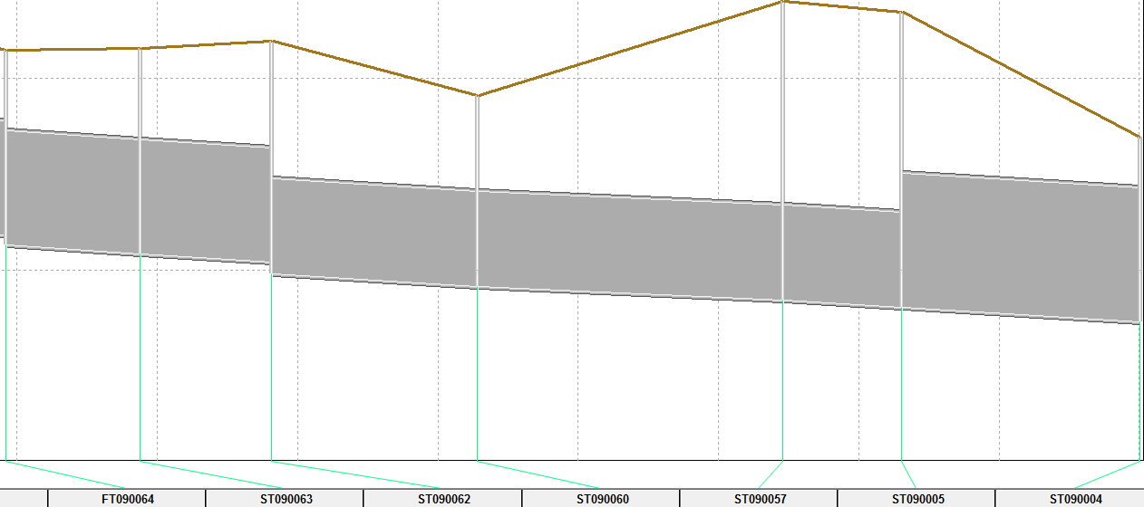
- Should the 2 pipes between ST090108 and ST090005 be lowered to match the adjacent pipes? The invert of ST090006 is known in the GIS, and the adjacent pipes on either side were interpolated using pipe slopes. The profile is shown below.
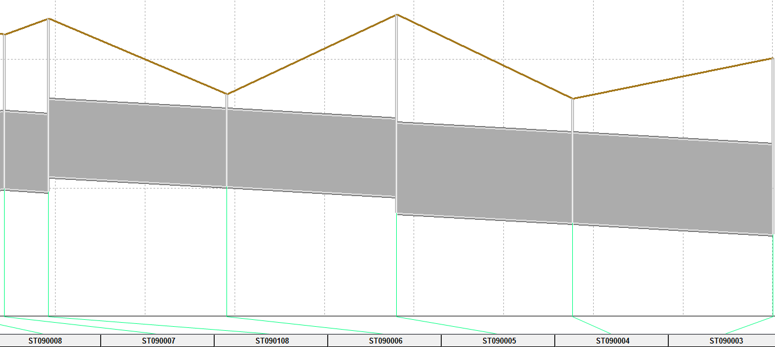
- The pipe from ST090017-ST090016 has a slope of 0.18% in GIS. However, the upstream invert is 647.92 feet, the downstream invert is 649.49 feet, and the length is 167 feet, giving it a calculated slope of -0.94%. It appears that one or both of the inverts are incorrect, most likely the downstream invert since that one makes the pipe too high. The invert at ST090015 is not listed in the GIS, and the pipe slope from ST090015-ST090014 is also unknown. Unless better information is available, we will throw out the GIS elevation for ST090015 and interpolate accordingly. The profile is shown below.
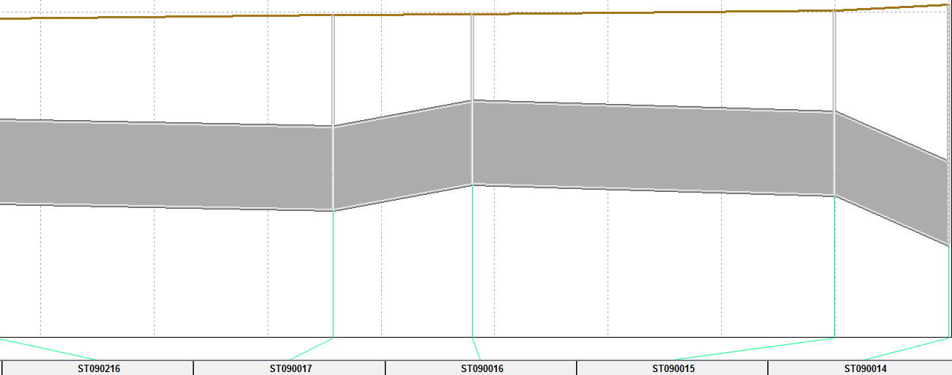
- There are 7 locations along the ditch system to the south where the ditch appears to pass through a culvert, as shown on the attached map. If you are confident they do not create a hydraulic restriction, we can ignore them. If we ignore the culverts but they do in fact act as restrictions, the flow may not be properly attenuated. Your guidance is requested.

