Date: July 28, 2026

To: Chris Carlson, Collection System Manager

Copy: Asher Fink, Hydrologic & Hydraulic Modeler

From: Jennifer Kampa

Re: Missing / Suspect Storm Sewer Utility Data and Hydrology Concerns

Adjustments were made to the model input as per the email from Asher Fink dated 6/17/13. The following items still need to be addressed.
- GIS planimetric data (edge of pavement, driveways, & building footprints) are needed to calculate the impervious percentage for each subcatchment in the model. We currently only have for combined areas. Please provide Donohue with the planimetric data.
- We have no size, slope, material, or elevation data for the pipes highlighted in yellow on the attached map. These may need to be surveyed or record drawings checked.
- The GIS shows a 36” cross-connection between ST090062 and the CB09008A, as shown in the picture below of the Hammond/N 31st St. intersection. The response to this concern from Superior was that the cross-connection was most likely an error in GIS. However, if the cross-connection does indeed exist, it would explain why the pipe size changes from a 72” upstream of ST090062 to a 60” downstream of ST090062 (question 15 from the previous memo). We recommend that manhole ST090062 be opened to verify whether or not the pipe to the south exists.
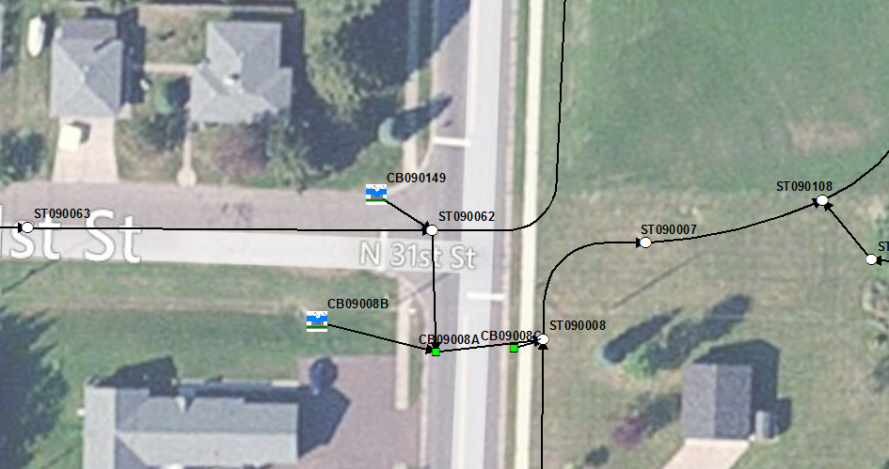
- The topography shows that the airport area generally drains to the northeast, but it is unclear where it goes from there. It appears that there is a shallow ditch running east-west (labeled below), but it is difficult to determine whether it flows west into Weeks Ave and eventually Faxon Creek or east through a couple of railroad culverts to the unnamed tributary ditch (more likely).
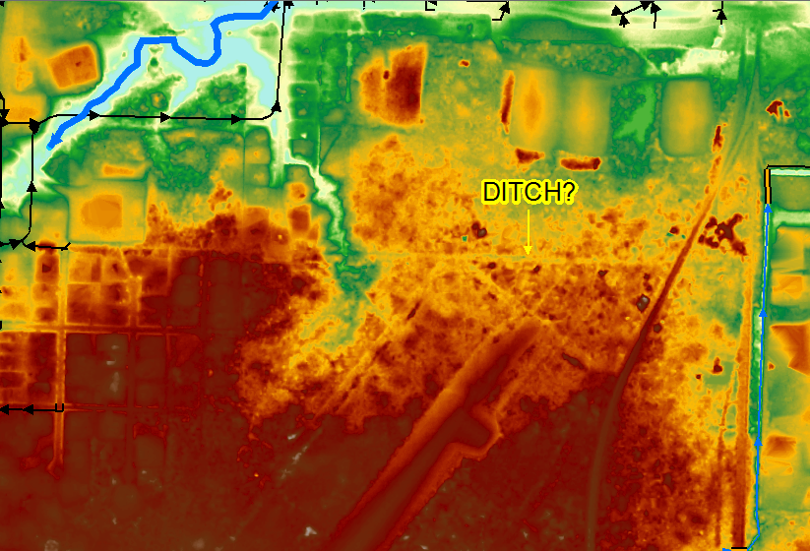
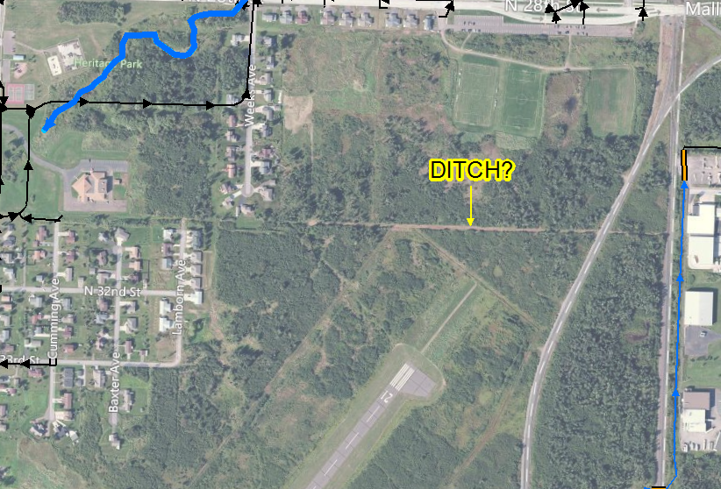
- There are seven locations along the ditch system to the south where the ditch appears to pass through culverts (indicated on attached figure). We request Superior inspect these for size, shape, material, and elevation (if possible). The mapped locations were estimated based aerial photography and contours. Any additional culverts found in the field that are not indicated on the map should be similarly inspected.

