WebClock Manager User Guide

Last Updated by City of Superior – June 2021

Step 1: Log In

Navigate to the TCP Manager Log In at: https://273440.tcplusondemand.com/app/manager/#/ManagerLogOn/273440

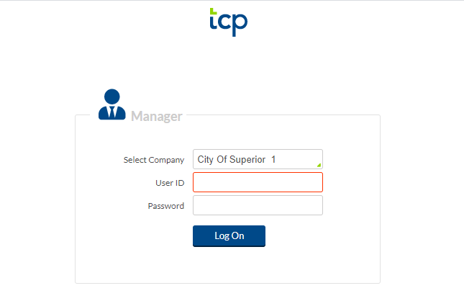

Enter your User ID number and Password. Then click Log on. The first time you Log on you will not have a password yet. Type in your User ID which is the first letter of your first name followed by your last name. Example: Ashley Puetz = APUETZ. Then click Log On. The system will prompt you to set a password.

To update your password at any time, click on your name in the upper right hand corner. There will be a drop down box. Click My Options.

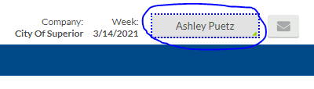

Click on the Passwords tab, drop down the system access menu and enter your current and new passwords.

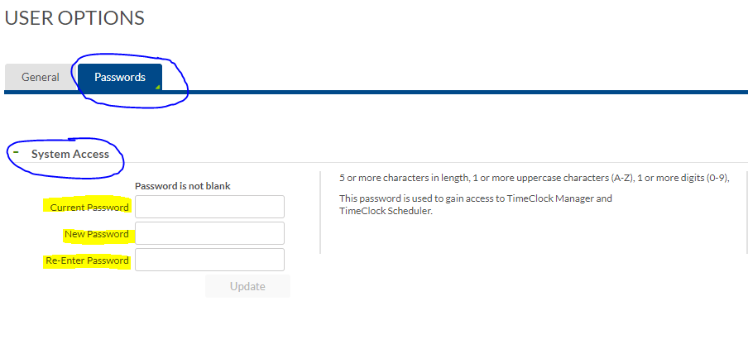

2. Set up Email for Notifications

Click on the General tab. Enter your email in the designated box.

This will send email notifications to you for things such as approving time off requests.

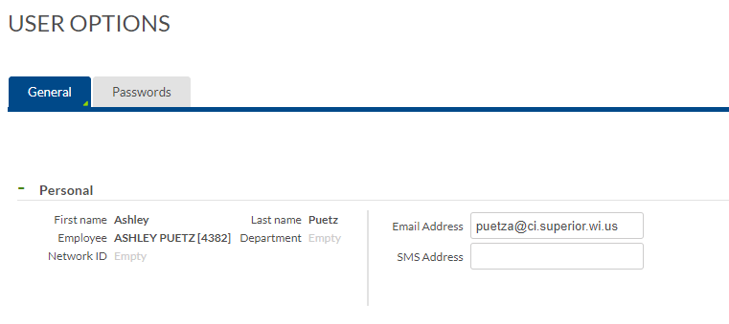

2. Set up Default Filters

You likely have access to more employees than those who you regularly sign off for. If this is the case and you would like to add a filter, navigate to your name in the upper right and select “My Options”. Then under Global Filters, click “Use Global Filter”. Then click “Employee Filter”.

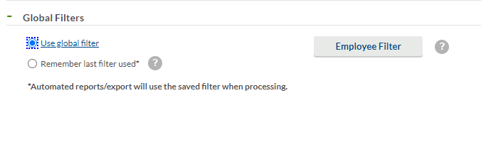

Select “Employee ID” and then click “Select”.

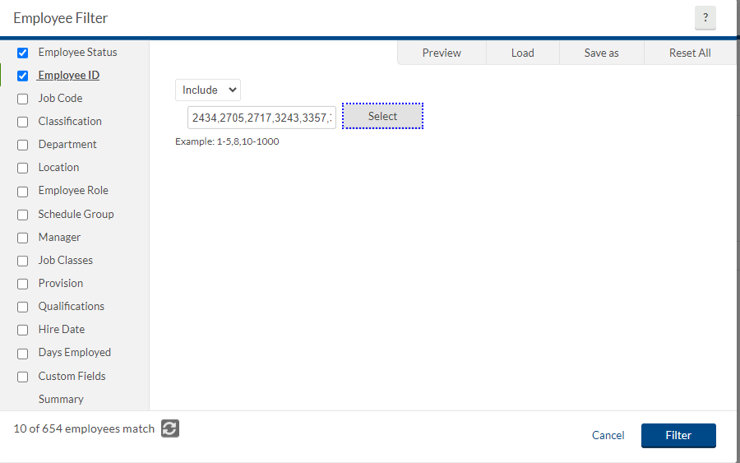

Next, you will likely need to click “Deselect All”. Then use the search bar to enter the employees’ names or ID numbers you want and click the box to the left of their name. If there is a blue check mark, they are selected. Once you have selected all the employees you want to show up, click “Select”.

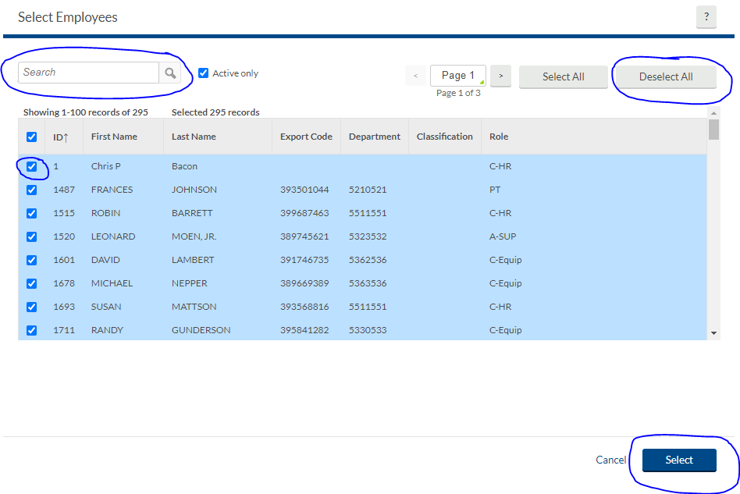

Next, select Remember last filter used.

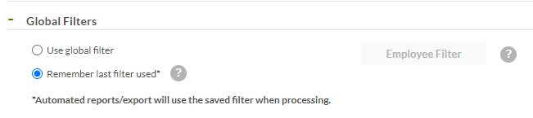

Now click “Save”.

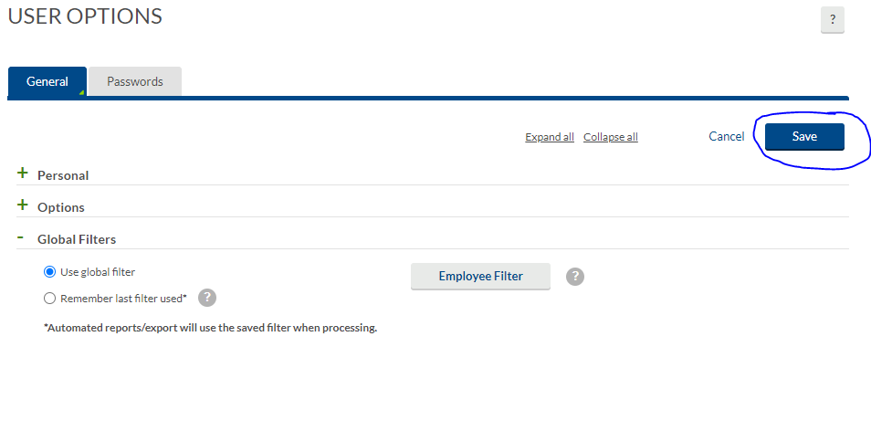

Navigate to “Hours, Individual Hours” on the blue menu ribbon and click “employee filter”.

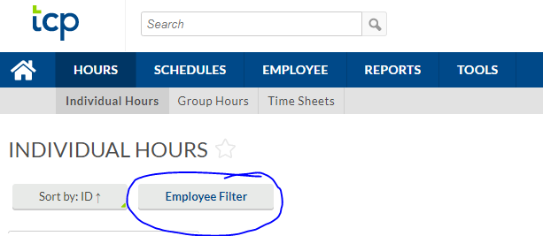

Click “Load” and on the dropdown menu click “Application Wide Filter”. Then click Filter.

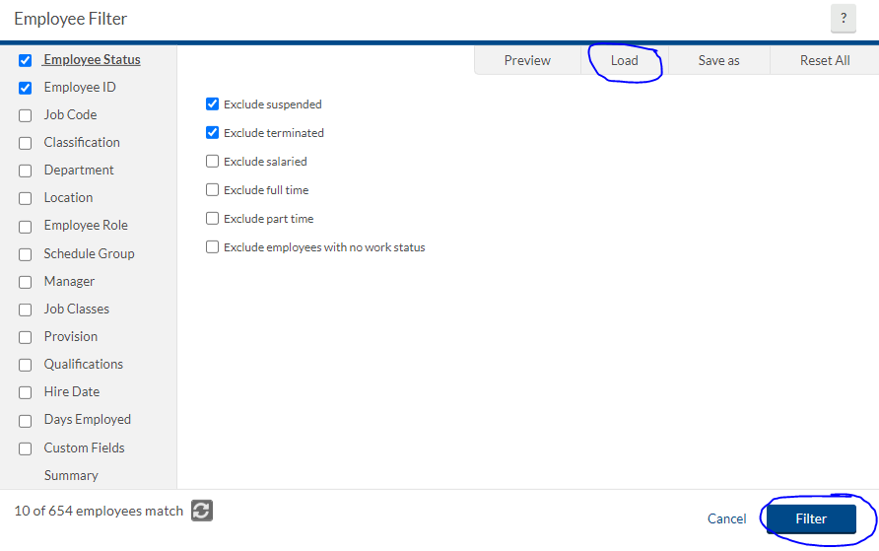

Once this is complete, the names of the employees you selected should show up in the left hand column. If you selected “Remember last filter used” earlier, this same filter will show up the next time you access this tab.

If you need to remove the filter, click reset all in the filter options and then click filter.

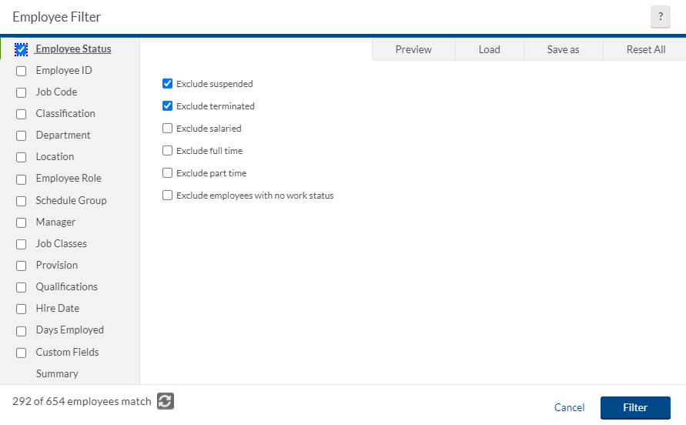

You may find that other filters may be more useful such as “Manager” or “Department”. Please follow the different prompts for each and determine which is best for you.

3. Approving Time

Manager approval can be added from the Individuals Hours tab or the Group Hours tab.

Individual Hours

Select an employee from the list you would like to approve hours for.

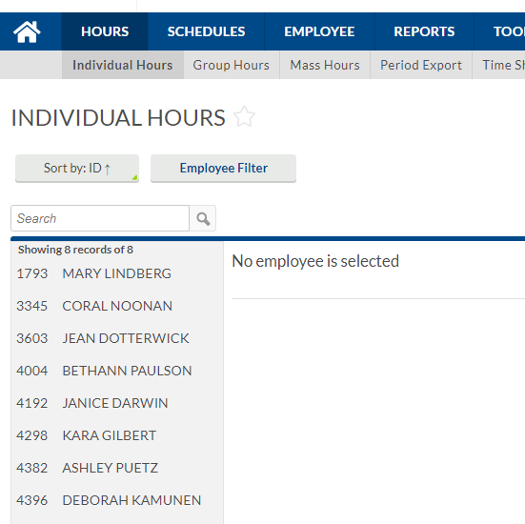

An employee’s time should look similar to below once you are ready to approve. Notice that there are red dots next to the time. This means there is an error that will not allow this time to be processed with payroll. In this case the error is that the time still needs manager approval.

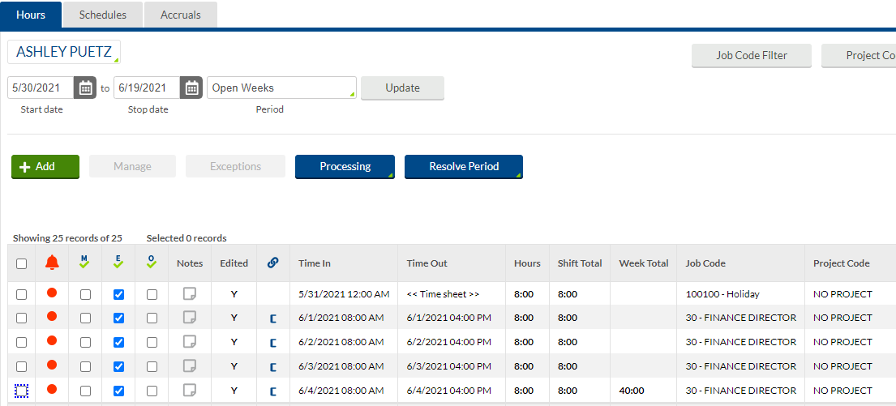

If the time entered looks correct, click the box in the M column or click the M box to check off for manager approval on all time sheet entries.

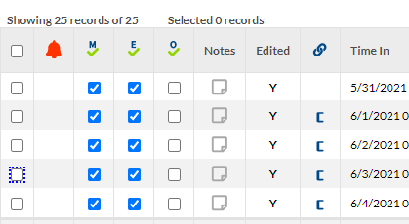

If any of the notes are turned blue, make sure to review the data by clicking on the blue note. If the employee needs to be paid at a specified rate, a note on that time should be included.

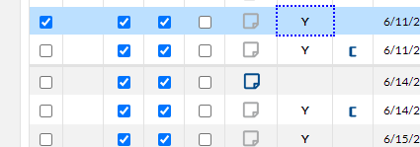

If you need to edit the note, click the pencil. If you need to delete the note, click the red delete.

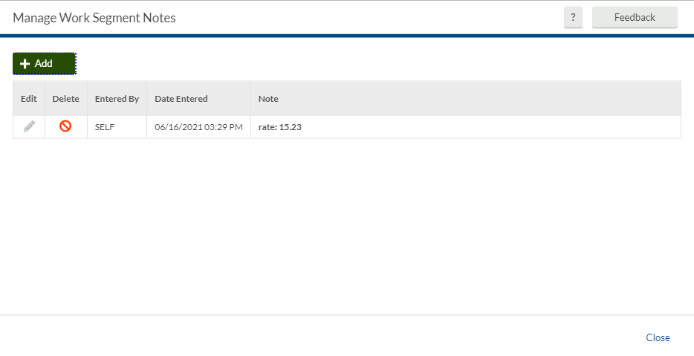

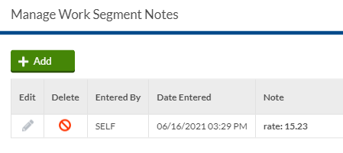

Group Hours

You can also approve time under Group Hours. Select a filter to help you trim the list of employees you would like to approve time for. This view allows multiple employees’ time to be seen at once.

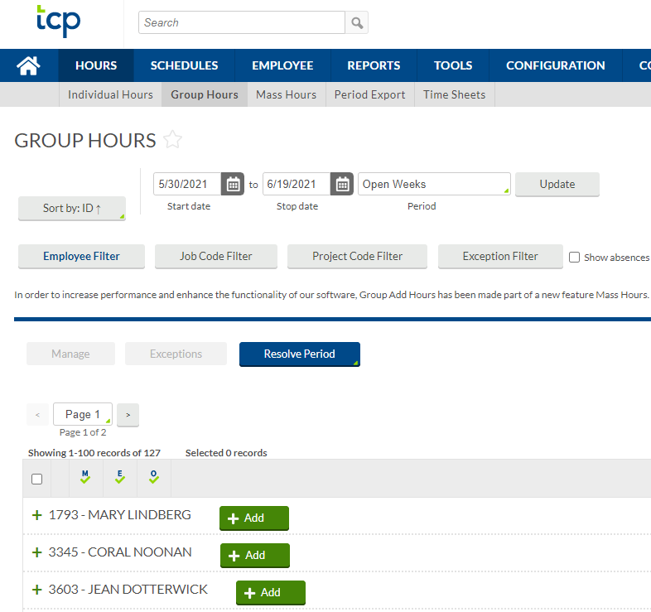

4. Approving Requests

Navigate to your dashboard by clicking on the home in the blue ribbon.

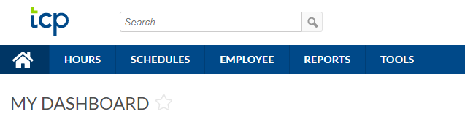

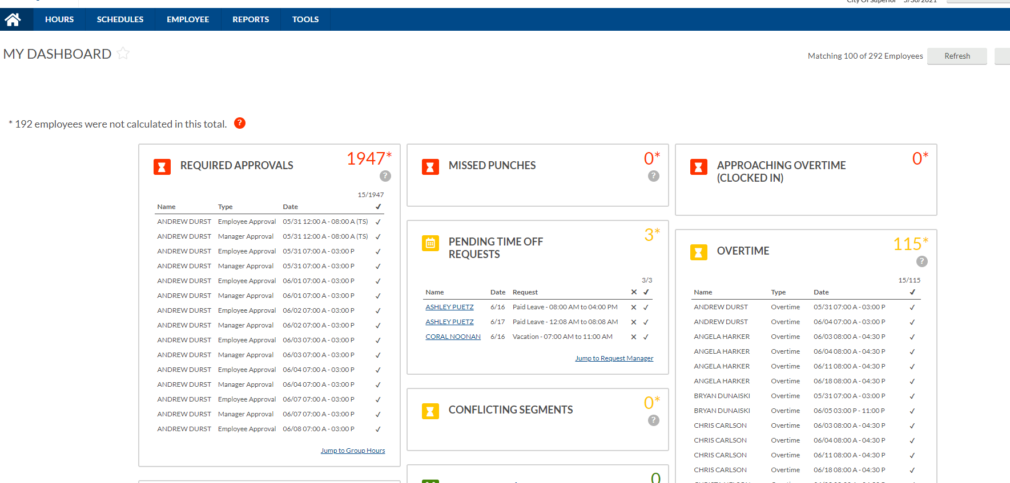

Look at the Pending Time Off Requests box. You can either select the X to deny or check mark to approve. You can also click Jump to Request Manager. 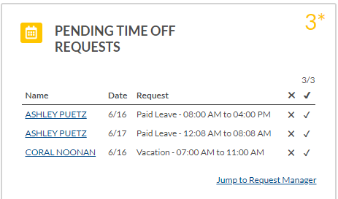
Right click on a pending request and select deny or approve level 1 from the drop down list. Once you approve, the time would appear on an employee’s time sheet.

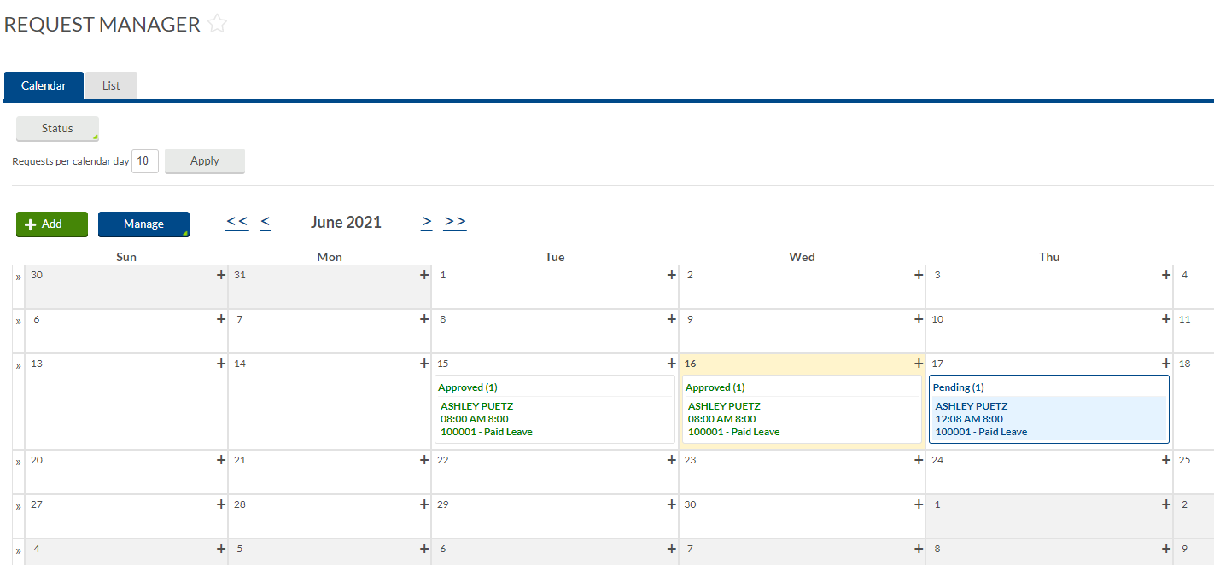

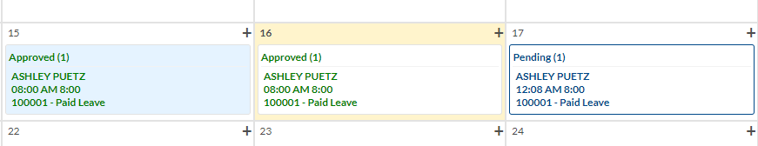

5. Customize Dashboard

Your dashboard is customizable. Click Edit from the My Dashboard home page.

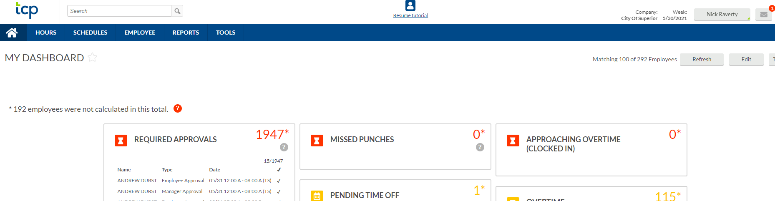

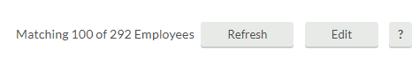

Each icon is called a widget. From here you can click the red x on any widget you wish to delete or use the add widget box to search through the drop down menu of widgets you would like to try.

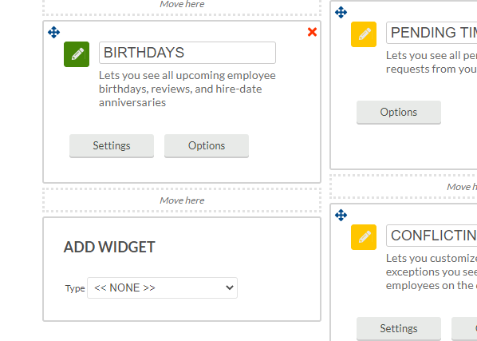

Click Save when you are done editing.
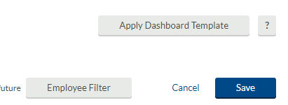

6. Schedules

You can view schedules for any of the employees assigned to you. These schedules are what is used to prepopulate time for individuals on their timesheets. If you notice an employee needs an update to their schedule, notify Finance/HR and we can make this change.

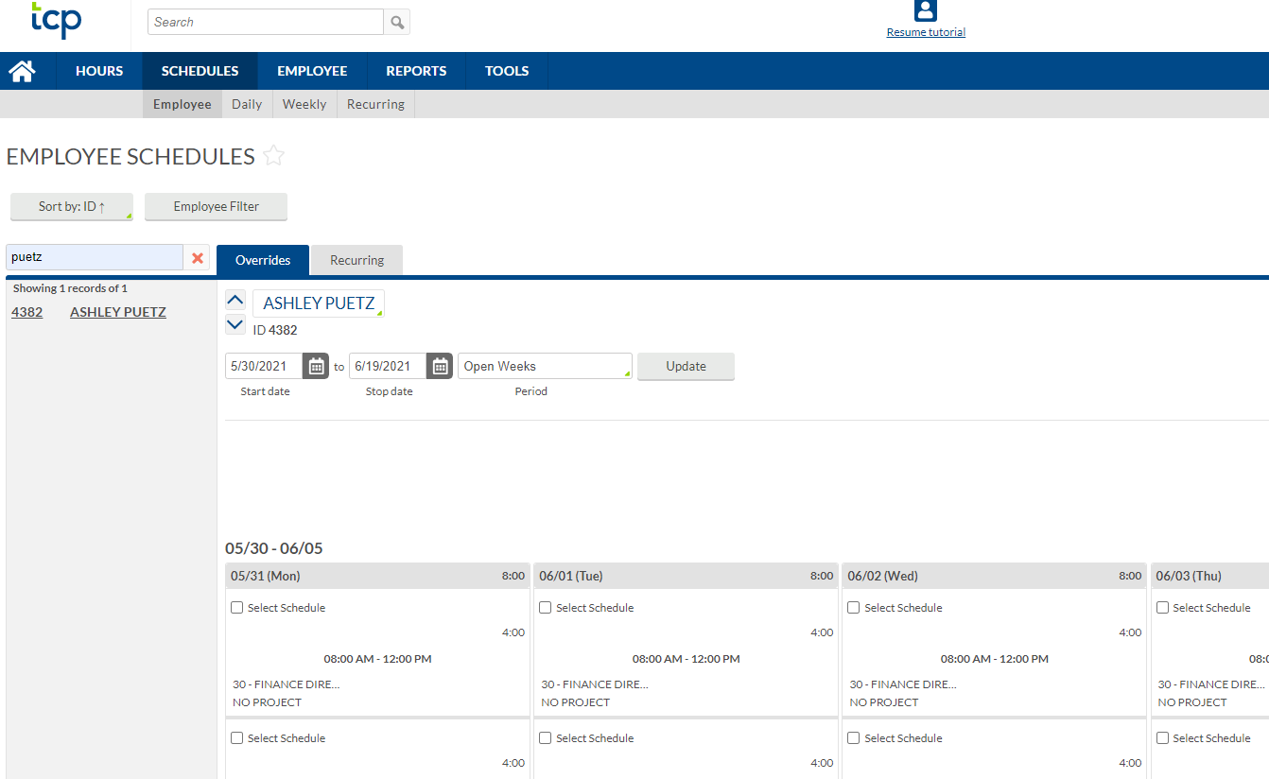

7. Accruals

You can view accruals for any of the employees assigned to you. Click Hours on the blue ribbon, click Individual Hours on the gray ribbon. Then click on the employee that you would like to view accruals for. Click Accruals. From here you will see all banks of time available to the employee.

Official record of employee accruals are kept in Central Square. Accruals are imported into Central Square after each payroll cycle to keep them updated. TCP will not allow employees to take banked time that is not available to them. If you notice an employee’s accruals are not correct, please contact Finance/HR to fix.

